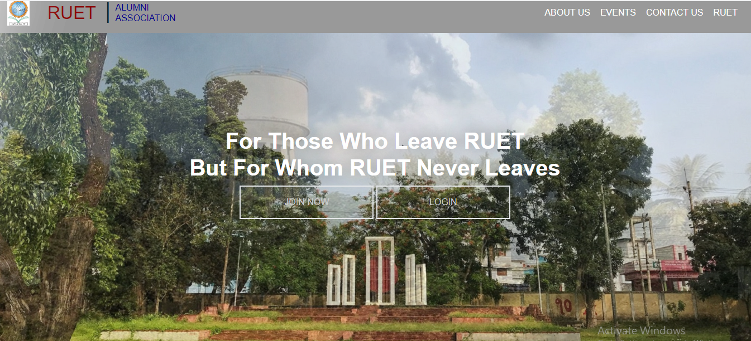

Features of this website

-Our ex students of RUET can sign up by their name and password and join by using some spacific information.

-They can see the current events of RUET

-If the students have any message to ask or to say about RUET they can leave it and admin of this website can see it.

-They can contact directly to the authority and also can go to RUET website.

-If the user want to see the newly joined teacher and if they want to find his seriesmate they can.

